

**Tribhuwan University**

**Faculty of Humanities and Social Sciences**

**Archery Master**

**A Project Report**

**Submitted to**

**Department of Computer Application**

**Kathmandu BernHardt College**

***In partial fulfillment of requirements of Bachelor in Computer Application***

**Submitted by**:

|  |  |
| --- | --- |
| Name | Roll No. |
| Rohit Gopali | 4610588 |
| Bishwas Shrestha | 4610572 |
|  |  |

**March, 2021**

**Under supervision of**

**Kumar Prasun**

# **Chapter 1**

# **Introduction**

## **Introduction**

The project title is called Archery master, and is based on the 1992’s classic bow and arrow game played on MSDOS back then. Nowadays in the market there are many games which require high graphics and a more reliable pc, introducing you the simple bow and arrow game that gives the experience on playing on a big screen with more frames adding fun sound effects and increase in difficult as the player scores frequently making it more competitive. This game category is competitive arcade. The game is very simple, the aim of the game is by tapping any key, shoot the arrows aiming on the board or center of the board for more points and bonus. Player will have limited arrows to shoot. Shooting at the perfect center of board gives a bonus arrow and extra points. It’s challenging game for all. This Archery master game is implemented for only desktops.

## **Problem Statement**

In the current scenario the game is just a basic arcade game with no multiplayer services to the players.

## **Objective**

* Experience the classic MSDOS games.
* Prevent boredom
* To create web-application.
* To creative a competitive and challenging arcade game.

## **Scope and Limitation**

### **1.4.1 Scope**

When we talk about videogame development, we often read that the rate of project abandonment is very high. And it’s true; developing a videogame is about putting forward a basic and fundamental concept: it is a computer project that requires many hours of work, dedication, effort and sacrifice. Based on prototypes, some personal touches, upload it to Steam. Create a game that is fun, attractive, with the right functionality, and with enough marketing to be seen among the many games that are published every day. Later version may be developed for Android.

## **1.4.2 Limitation**

* No multiplayer facilities
* Requires internet connectivity
* Browser should support jQuery’s version 3.2.1 or higher.

## **Organization of Report**

Chapter 1 consists of instructions, problem statements, objectives, scope and limitations regarding the project

Chapter 2 describes the fundamental theories and concept as well as information about existing system, journals and references.

Chapter 3 summarizes the keynote on system analysis and design where description of use case diagram, performance & reliability, diagrams, database and architectural design.

Chapter 4 summarize on implementing and testing, tools used for preparation of the project. Test case as well as integration testing are done.

Chapter 5 summaries of outcome of the project, conclusion, reviews as well as future recommendations, improvements that can be done on upcoming days and feedback system.

# 

# **Chapter 2**

# **Background Study and Literature Review**

## **2.1 Background Study**

Actually, game is entertaining and competitive for anybody and in leisure time. The bow and arrow game implemented for only desktop. Concept of the game is shooting the arrow aiming the board for points. Player will have limited arrows and gain an arrow if arrow hits the perfect center of the board and an extra point. As the score increases the level becomes more complicated. The arrow can be shot by the player using the mouse left click. The concept of this game came from the classic bow and arrow game where player pops the balloons using arrows as shown in figure 1.

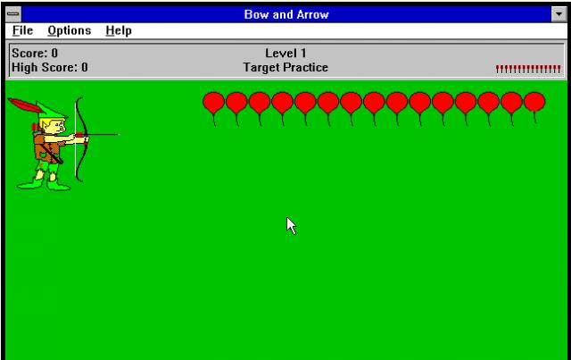

Figure 1 classic bow and arrow

## **2.2 Literature Review**

A duck hunt was developed using Xilinx ISE Design Suite 14.6 by ‘Burkhard Englert, Ph.D. (Chair) John Tramel, M.S. Michael Chelian, Ph.D.’ student of California State University, Long Beach. The PC controls of this game are also simple. You just have to use the left click of the mouse for shooting the duck. The game is on until you run out of bullets to shoot the ducks. All the gaming function is set from Digilent Adept, Xilinx ISE Design Suite 14.6 and Digilent JTAG HS1 Programming Cable.[1]

According to ‘Drew Tisdelle’ of WORCESTER POLYTECHNIC INSTITUTE who studied Interactive Media and Game Development, created a JavaScript library hybrid physical/digital board games using JavaScript libraries. The library started with the idea of creating a board game playable on standard mass-market tablets that would demonstrate that specialized hardware is not needed to create hybrid physical/digital games. The library was named Minotaur’s Labyrinth library shortly it was called Minotauros library. The Minotauros Library has been released publicly on the online software hosting platform GitHub. Once posted, the library will continue to be updated and improved based on user feedback. It is hoped that the library will encourage the wider development of tablet-based board games, without the need for specialized hardware. The library is named after both the game concept as well as the Minotaur itself, the mythological blend of man and bull, just as the library is meant to help blend physical and digital game. According to their testing phase of the project the library was indeed working as intended. The game was correctly registering pieces at the start and was able to accurately detect the pieces when they were placed down on the screen.[2]

As studying JavaScript and html canvas, physic for JavaScript game book by ‘Dev Ramtal and Adrian Dobre’ they explained about the physic used in a JavaScript game with an example of a bouncing ball. Physic is the study of natural laws that defines how the things behave. The laws are simple and can be coded. The canvas drawing API helps in draw things using only tools combined with math and physics. Canvas helps in rendering graphics and adding aminations objects like 2d in web browsers without any external plugins such as flash player.[3]

# **Chapter 3**

# **System Analysis and Design**

## **3.1 System Analysis**

### **3.1.1 Requirement Analysis**

A requirement is a singular documented physical or functional need that a particular design, product or process aims to safety. It can be divided into functional requirements and non-functional requirements.

#### **3.1.1.1 Functional Requirement**

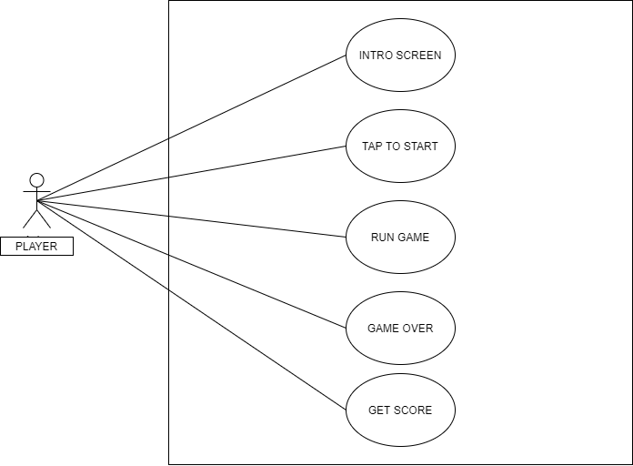

Figure 2 Use case diagram of Archery master

* 2D Animation: 2D animations are used for the arrows, rope in bow and bonus score fade away.
* Objective Selection: Arrow object which aim to hit the board and gain a score and a bonus arrow if arrow hits the perfect center of board.
* Moving board: The board will start to move if the player uses certain arrows or gain a certain hitting the board continuously.
* Collision Detection: When the arrow hits certain area the board, the score is decided how far the arrow landed from the center, closer the area higher the point. Maximum point player gets touching center of board is 8 and a bonus arrow.
* Score counting: If arrow touches certain area in board player gets a score/

#### **3.1.1.2 Non-Functional Requirement**

1. Performance

* Best performance even with minimum hardware spec.
* Performance depends upon on web browser and supportability of JavaScript version.

1. Security

* Not related with any privacy theft or any special user access
* Does not require any personal information.
* No special access required.

1. Economical requirements

* This game is based and created using a free and open-source platform.
* No extra application or services purchased.

### **3.1.2 Feasibility Analysis**

A detailed investigation and analysis conducted to determine the financial, economic, technical, or other advisability of a proposed project. Part of the systems development life cycle which aims to determine whether it is sensible to develop some system.

1. Technical feasibility

* It has been within the limit of current technology. Can run on minimum pc spec. The system has been developed using open-source tools and platform. Performance may differ from web browser versions, specification to run the JavaScript.

1. Economic feasibility

* It is economically feasible because it is developed using open-source tools.
* No paid software of third-party tools is used.

1. Operational feasibility

* It is supposed to be a free application so will be easily available to all the users.

### **3.1.3 Data Modeling**

For the data to be stored in database, the data models of the project are created on the basis of ER model and unified modelling language. All data required by the database are accurately represented. For the designing of the application, entity relationship diagram has been used.

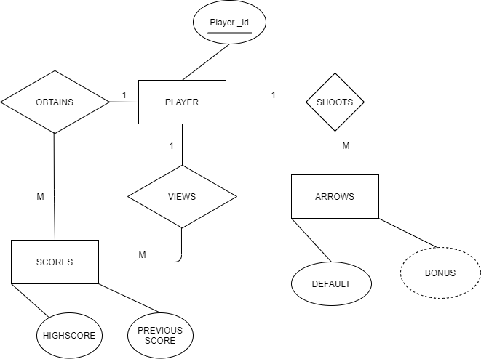

Figure 3 ER diagram of Archery master

Archery master entities and their attributes:

* Player Entity: Attributes of player is player id
* Score Entity: Attributes of Scoreboard are high score and previous obtained score.
* Arrows: considering arrows as an entity with default and bonus attribute.

This ER (Entity Relationship) Diagram represents the model of Video Game. The entity-relationship diagram shows all the visual instrument of database tables and the relations between Scoreboard, User, Login, Roles, etc. It used structure data and to define the relationships between structured data groups functionalities. The main entities are Player and Scoreboard. In the above figure Player_id is the primary key i.e., a unique attribute and 1 and M specify one to many relationships.

**3.1.4 Process Modeling**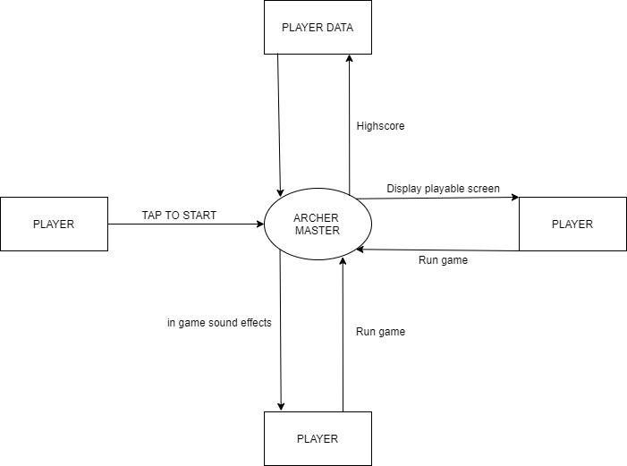

Figure 4 : Level 0 DFD

Level 0 DFDs, also known as context diagrams, are the most basic data flow diagrams. They provide a broad view that is easily digestible but offers little detail. Level 0 data flow diagrams show a single process node and its connections to external entities.

DFD stands for data flow diagram Above figure is the Zero Level DFD of Archery master, where elaboration of the high-level process of Video games is done. It’s a basic overview of the whole project or process being analyzed or modelled. This deals with one or more of the data flows to or from an external agent, and which together provide all of the functionality of the Video Game System as a whole. It also identifies internal data stores of user.

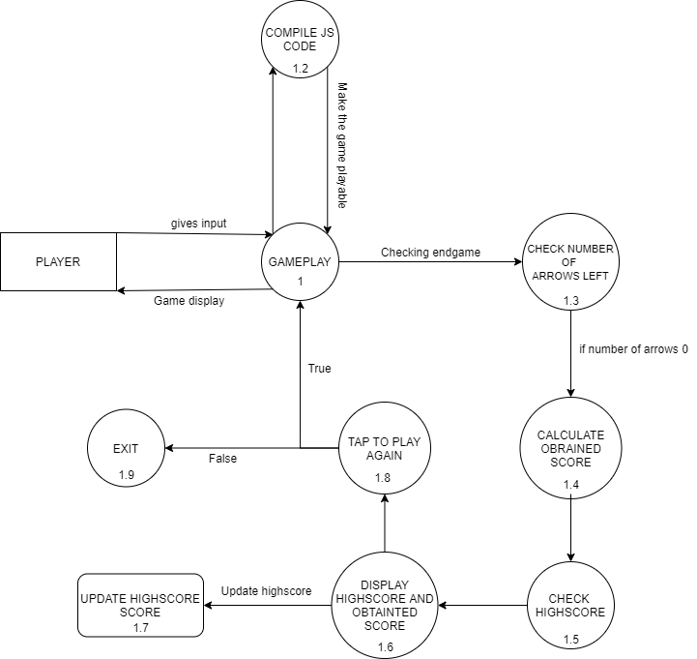

Figure: 5 Level 1 DFD of Archery master

First Level DFD (1st Level) of Archery master shows how the system is divided into sub-systems (processes), It may require more functionalities of the project to reach the necessary level of detail about the Video Game functioning. It shows the detailed process how game works.

## **3.2 System Design**

### **3.2.1 Architectural Design**

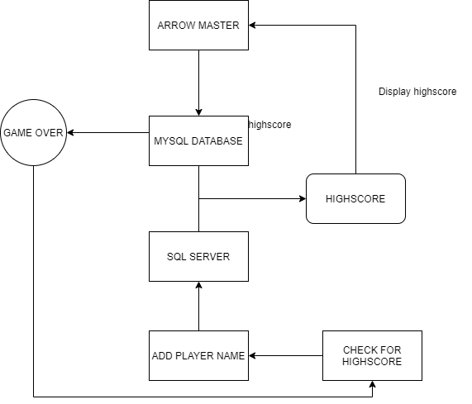

Figure 6 :Architectural design of Archery master

Server’s main responsibilities are verifying user information, transmitting data between users through server, storing user records, and providing user records upon request. The webpage is a static website with a leaderboard that displays the username and ranking of Each user. Users can view the top performers over various windows of time and search for Rankings by username.

### **3.2.2 Database Schema**

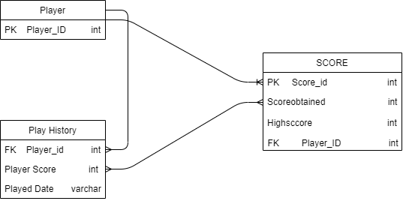

Figure 7: Database schema of Archery master

It is the skeleton structure that represents the logical view of the entire database. It defines how the data is organized and how the relations among them are associated. It formulates all the constraints that are to be applied on the data.

The database schema if Archery master represents its entities and the relationship among them. It contains a descriptive detail of the database, which can be depicted by means of schema diagrams. It’s the database designers who design the schema to help programmers understand the database and make it useful.

### **3.2.3 Interface Design**

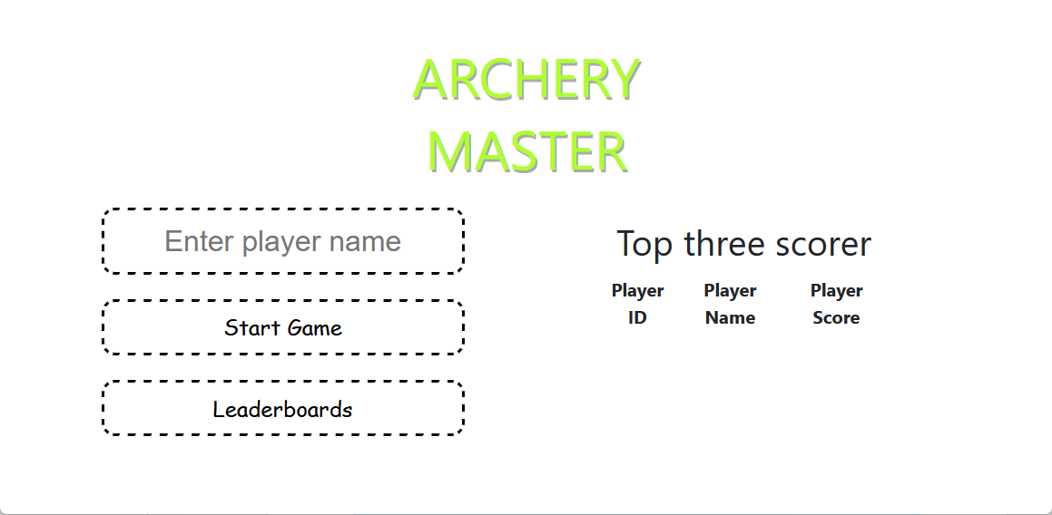

Figure 8: Main Menu

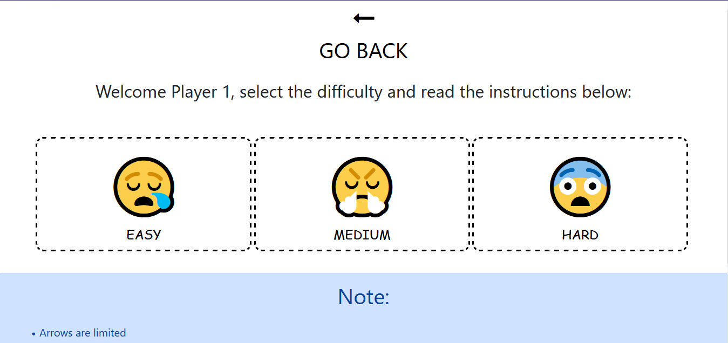

Figure 9: Select Difficulty

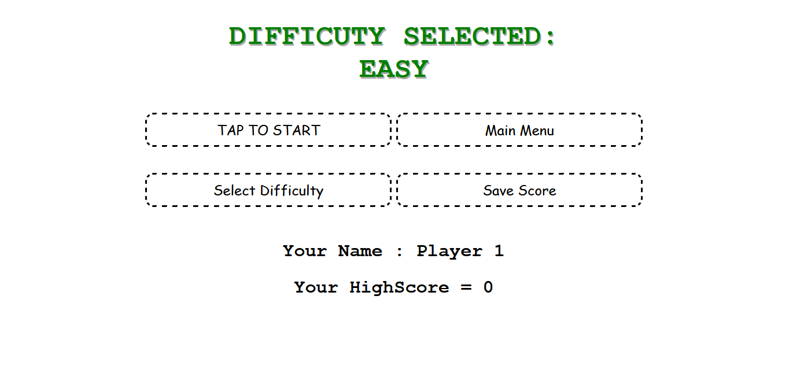

Figure 10: Selected difficulty Menu

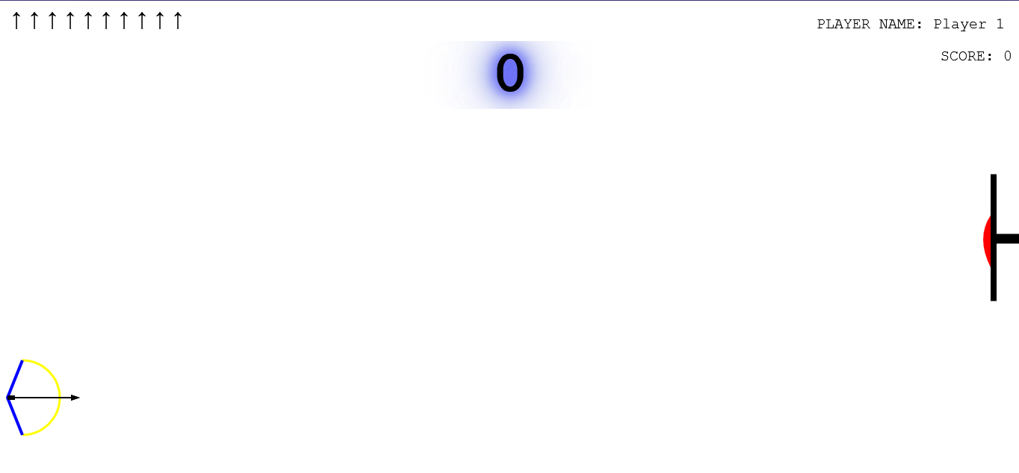

Figure 11 :Gameplay

### **3.2.4 Physical DFD**

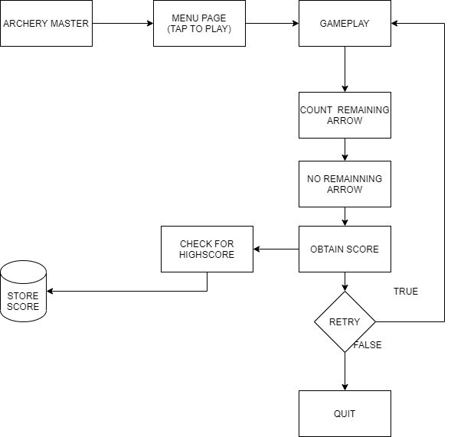

Figure 12: Physical DFD of Archery master

Physical DFD of Archery master shows how the system is divided into sub-systems (processes), each of which deals with one or more of the data flows to or from an external agent, and which together provide all of the functionality of the video game system as a whole. It also identifies internal data stores of users. This shows the interaction between the game and the user and all the actions that the user can perform in game.

**Chapter: 4**

# **Implementing and testing**

## **4.1 Implementing**

### **4.1.1. Tools Used**

* Sublime Text

The coding of this project was done in free and easy to use text editor called sublime text 3.It natively supports many programming languages and markup languages, and functions can be added by users with plugins. Sublime Text 3 is a lightweight, cross-platform code editor known for its speed, ease of use, and strong community support.

### **4.1.2 Implementation details of modules**

* HTML

HTML stands for Hyper Text Markup Language. HTML is the standard markup language for creating Web pages. HTML describes the structure of a Web page. HTML consists of a series of elements. HTML elements tell the browser how to display the content.

* HTML Canvas

The HTML canvas element is used to draw graphics, on the fly, via JavaScript. The canvas element is only a container for graphics. You must use JavaScript to actually draw the graphics. Canvas has several methods for drawing paths, boxes, circles, text, and adding images.

* JS JavaScript

JavaScriptis a scripting or programming language that allows you to implement complex features on web pages — every time a web page does more than just sit there and display static information for you to look at — displaying timely content updates, interactive maps, animated 2D/3D graphics, scrolling video jukeboxes etc.

* PHP

PHP (recursive acronym for PHP: Hypertext Preprocessor) is a widely-used open-source general-purpose scripting language that is especially suited for web development and can be embedded into HTML

* MySQL Database

MySQL is a relational database management system based on SQL – Structured Query Language. The application is used for a wide range of purposes, including data warehousing, e-commerce, and logging applications. The most common use for MySQL however, is for the purpose of a web database.

* Ajax

AJAX stands for Asynchronous JavaScript and XML. AJAX is a new technique for creating better, faster, and more interactive web applications with the help of XML, HTML, CSS, and Java Script. Ajax uses XHTML for content, CSS for presentation, along with Document Object Model and JavaScript for dynamic content display.

## **4.2 Testing**

### **4.2.1 Unit Testing**

Unit testing is a type of software testing where individual units or components of a software are tested. The purpose is to validate that each unit of the software code performs as expected. Unit Testing is done during the development (coding phase) of an application by the developers.

|  |  |  |  |  |
| --- | --- | --- | --- | --- |
| S.no | Test Case | Test data input | Expected outcome | Test results |
| 1. | Use of html canvas | Creating a canvas for display gameplay using <canvas>element | Styled canvas for the game display | Pass |
| 2. | Use of php to connect MySQL | Using php to connect to store data on SQL database using xampp apache server | Establish connection to database | Pass |
| 3. | Use of JavaScript for 2d animations | Creating gradual changes in an element's style to make it look continuous | Styling elements to make it look animated. | Pass |
| 4. | Use Ajax to send JavaScript variable values to php | Send score stored in JavaScript variable to php | Store player obtained score in database | Fail |
| 5. | Add audio to certain functions | Audio plays after certain action by player | Audio plays after performing certain functions | Pass |
| 6. | Get player name after the end game | Ask player name after game is over | Input field for player name after game is over | Fail |

### **4.2.2 Integration Testing**

Integration testing is a level of software testing where individual units / components are combined and tested as a group. The purpose of this level of testing is to expose faults in the interaction between integrated units. Test drivers and test stubs are used to assist in integration testing.

|  |  |  |  |  |
| --- | --- | --- | --- | --- |
| S.no | Test Case | Test data input | Expected Outcome | Test results |
| 1. | Tap any keys to play | Player presses any key on keyboard or left mouse click to being playing | Game starts and player taps to shoot | Pass |
| 2. | Get limited arrow | Only 10 arrows at the starting of the game | Start game with 10 arrows | Pass |
| 3. | Get point after arrow hits board | Player gets point as per the nearest area hit to the center of the board | Get a score while arrow hits the board | Pass |
| 4. | Get bonus | Get bonus for a perfect shot | After arrow touches the center of board player gets extra arrow | Pass |
| 5. | Moving board | After certain shots board starts to move up and down | After 8-10 shots board start to move | Pass |

# **Chapter: 5**

# **Conclusion and Recommendation**

## **5.1 Outcome**



Figure 12: Gameplay outcome

## **5.2 Conclusion**

The final project was planned, developed and demonstrated as expected. The project was done by using JavaScript which could be played on current version of windows. The main objectives of this web application are to experience the good old games.

The purpose of this project was to create a competitive game played in individuals based on the classic grossing game, it can be concluded that most of the objectives of the project have met yet there are further modifications and changes could be done in the future.

## **5.3 Recommendation**

* Design more complex game logic can increase our game integrity.
* Add bow and arrow skins
* Can be developed for androids and IOS devices.

# **References**

[1] <https://vuongducnguyen.com/documents/official_duck_hunt_fpga_game_report_vdn.pdf>

[2] https://www.worldcat.org/title/physics-for-javascript-games-animation-and-simulations-with-html5-canvas/oclc/1005807841

[3] https://www.worldcat.org/title/physics-for-javascript-games-animation-and-simulations-with-html5-canvas/oclc/1005807841